**ANIME WEBSITE**

**GOGOANIME**

#### Gogoanime is the right anime streaming website for anybody searching for an excellent collection of anime reveals and films. The website affords each English and Japanese audio and subtitles, and its search perform makes discovering your favourite anime simple. In addition, Gogoanime affords a variety of genres, from motion to romance, so there’s one thing for everybody. Best of all, Gogoanime is free to make use of

#### 

#### 

#### WEBSITE CONTAINTS

#### **HOME PAGE**

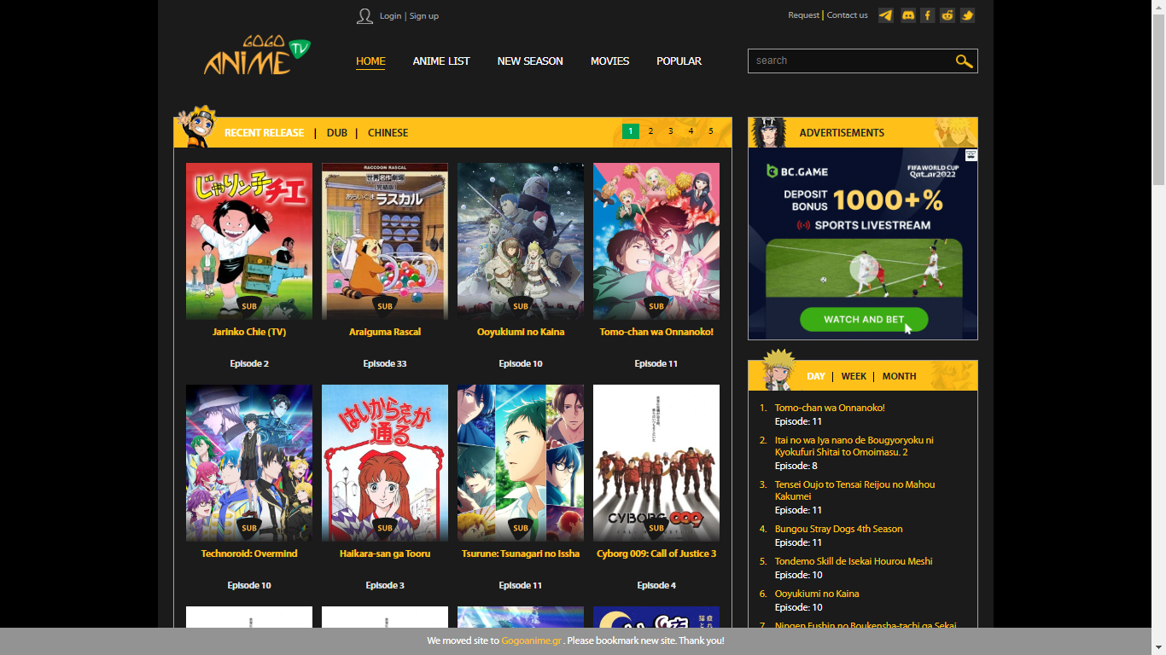

**Home Page:-**

* RECENT RELEASE|DUB|CHINESE ( Main content of the Home page. )
* DAY|WEEK|MONTH (Sub content of Home page )

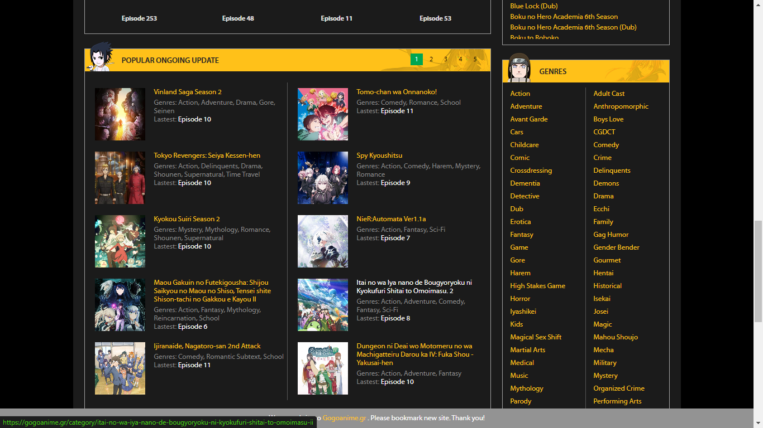

* POPULAR ONGOING UPDATE ( Sub content of Home page )
* GENRES ( Sub content of Home page )
* SEASONS ( Sub content of Home page )

**ANIME LIST**

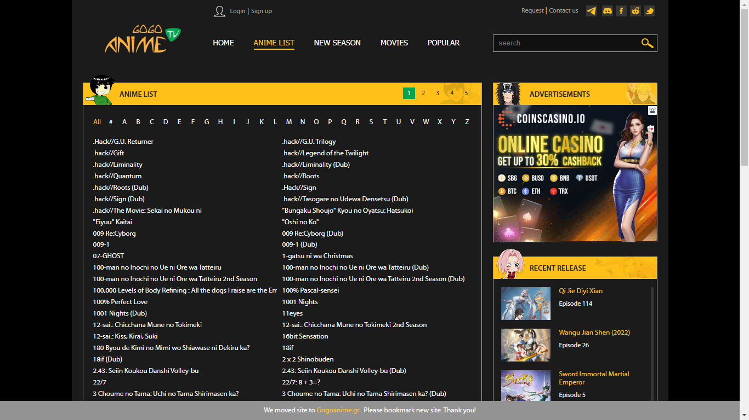

Anime List Page:-

* ANIME LIST ( Main content of Anime List Page.Which contain list according to A to Z )
* RECENT RELEASE ( Sub content of Anime List Page)
* SEASONS ( Sub content of Anime List Page)

**NEW SEASON**

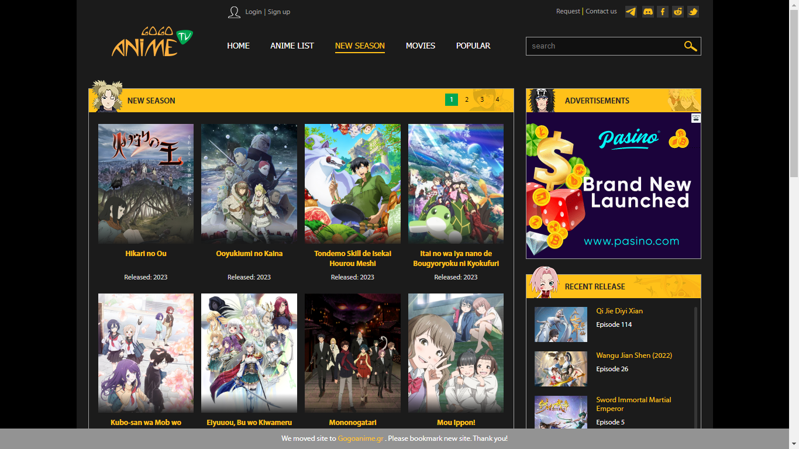

New Season Page:-

* NEW SEASON ( Main content of Anime List Page )
* RECENT RELEASE ( Sub content of Anime List Page)
* SEASONS ( Sub content of Anime List Page)

**MOVIES**

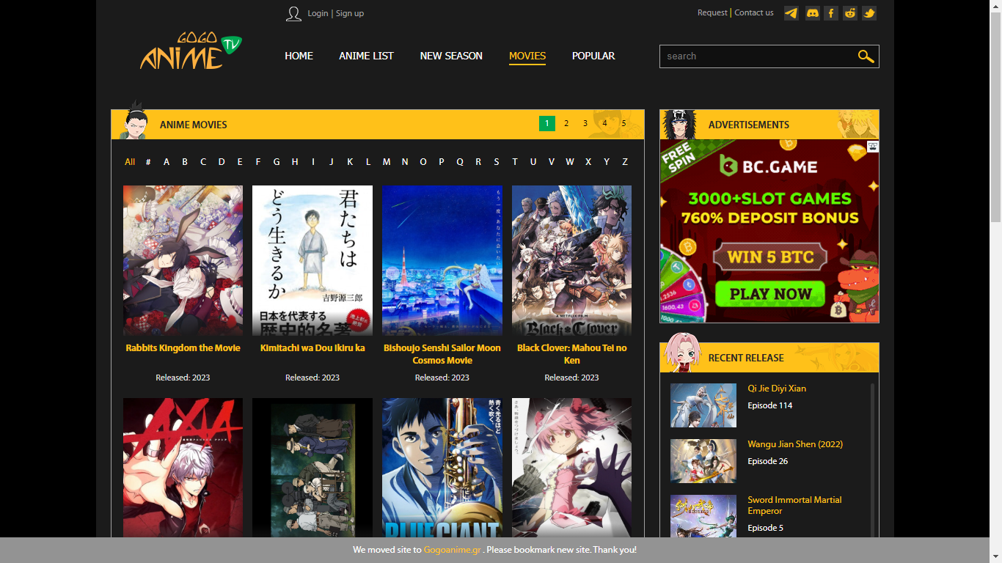

Anime Movies Page:-

* ANIME MOVIES ( Main content of Anime List Page )
* RECENT RELEASE ( Sub content of Anime List Page)
* SEASONS ( Sub content of Anime List Page)

**POPULAR**

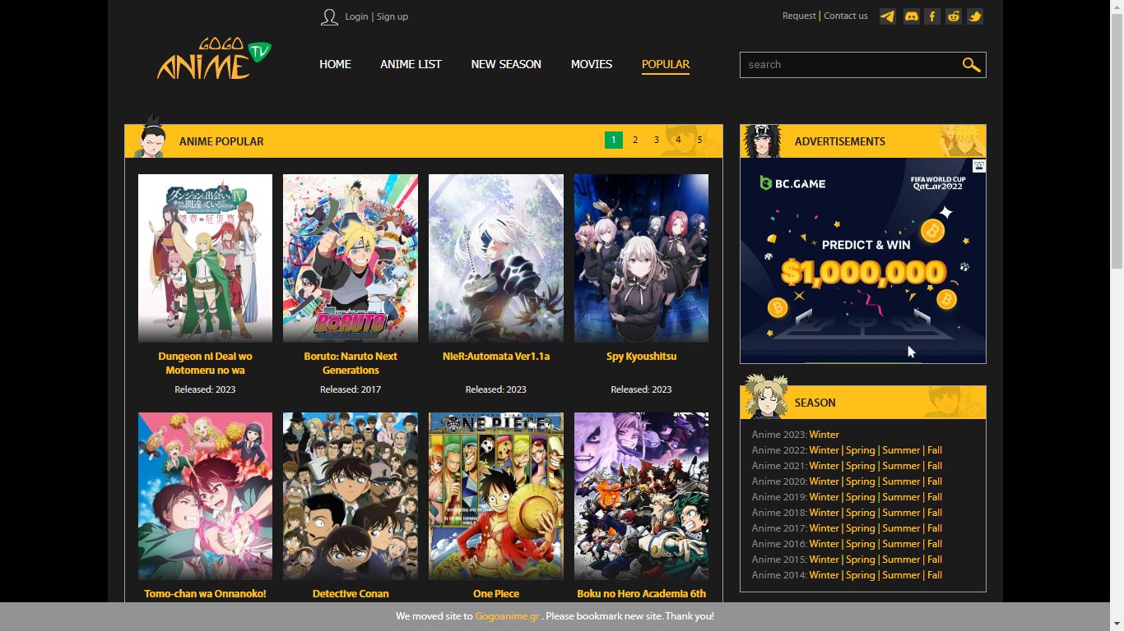

Anime Popular Page:-

* ANIME POPULAR ( Main content of Anime List Page )
* SEASONS ( Sub content of Anime List Page)

LOGIN PAGE

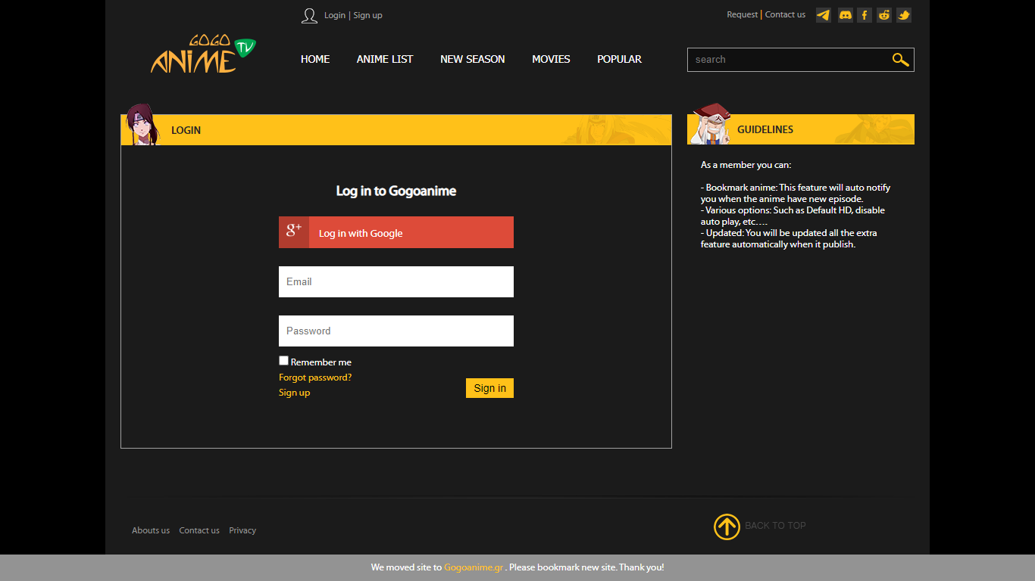

SIGN UP PAGE

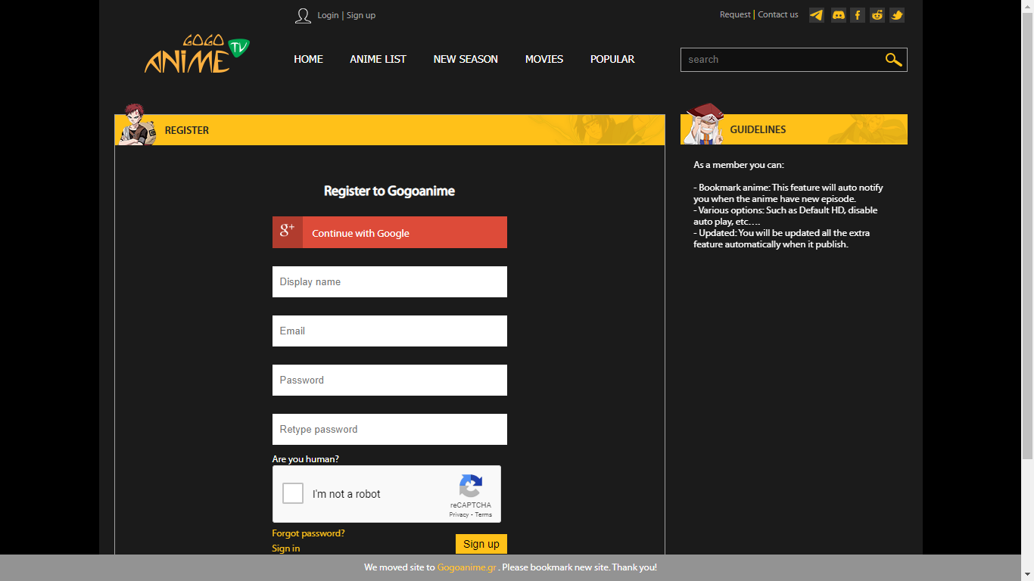



TECHNOLOGYIES USED IN WEBSITE

* Front-End:

1. Html
2. Css
3. Bootstrap
4. React

* Dynamic:

1. Javascript
2. Ci/cd and AWS
3. Login and logout(oauth and jwt)

* Database:

1. Mongodb
2. Json Data

* Code compilers:

1. Visual studio code
2. Git bash
3. Git hub
4. Node js.

